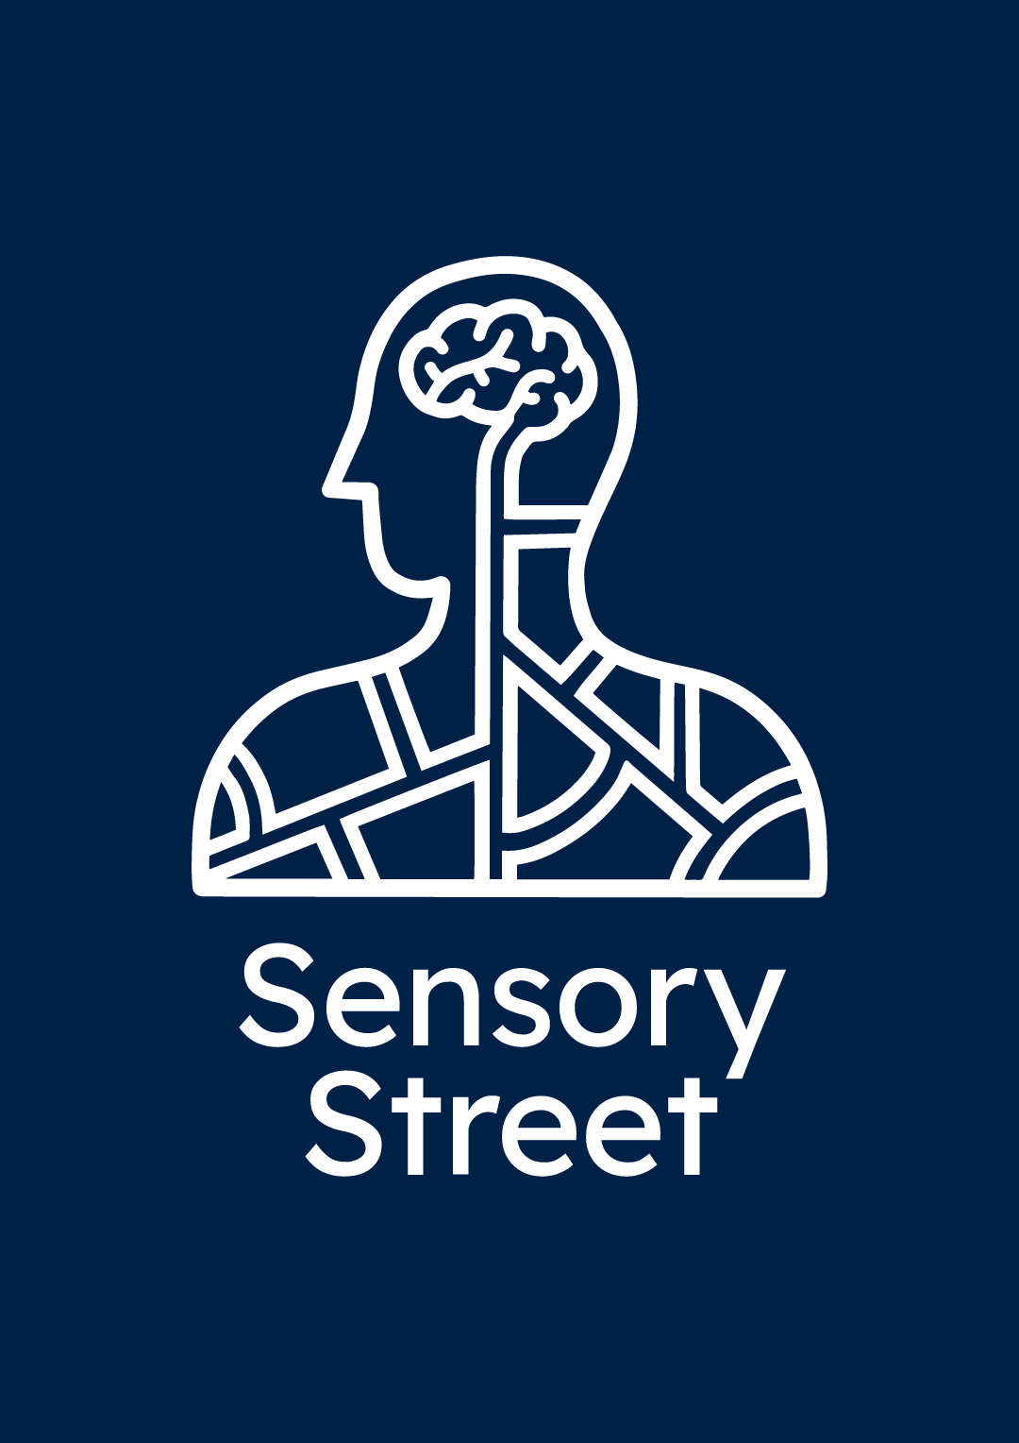
Press Pack

The Event
Sensory Supermarket

Date: 19-20th August 2022
Duration: 45 minutes per session
Tickets: Free but mut be booked in advance
Ticket Website: https://sensorysupermarket.eventbrite.com
Venue: PEARL (Person-Environment-Activity Research Laboratory, UCL), Yew Tree Avenue, Dagenham, RM10 7FN

- Are you interested in learning more about how businesses and organisations could make places more enabling for autistic people with sensory processing differences?
- Want to learn some strategies and tips to use in your own business or public space?
Then join us at the Sensory Supermarket on the 19-20th of August at PEARL (Person-Environment-Activity Research Laboratory) in Dagenham. It is a free event hosted by Sensory Street, a research project from the Universities of Oxford and Reading funded by the Wellcome Trust.
On the 19th-20th August we are taking over UCL's PEARL building to explore what aspects of public spaces can be disabling for autistic people with sensory processing differences.
Our event will bring together the findings from our focus groups and social media research to explore the sensory experiences of autistic people and what individuals and businesses could do to help make these spaces more inclusive and enabling.
At the Sensory Supermarket we will be sharing perspectives from autistic people from our research as well as ways that businesses can make easy adaptations to improve their space’s accessibility. The event includes an immersive supermarket experience designed in partnership with Sensory Spectacle, as well as video presentations, information boards and more.
This event has been developed with input from the autistic community. Each session is a self-lead experience, meaning you can spend as much or as little time exploring the space as you would like within your 45 minute time slot.
Please note: Part of this event aims to create a heightened sensory experience of a supermarket based on quotes from autistic people. Multisensory stimuli such as loud noises and strong scents will be present which some people may find more challenging. There will be designated quiet spaces for those who may feel overwhelmed.
Background
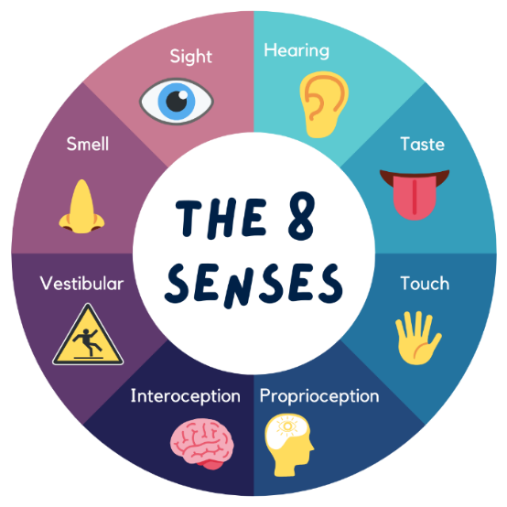
Autism is a neurodevelopmental difference in the way that people communicate and interact with the world around them. A recent research study identified that around one in 57 or 1.76% children in the UK are autistic (Roman-Urrestarazu et al, 2021). Other estimates have ranged from 1 in 44 (2.27%) in America (Maenner et al, 2018), 1 in 21 (4.7%) in Northern Ireland (Department of Health Northern Ireland, 2022), and 1 in 100 worldwide (Zeiden et al, 2022).
Autistic people commonly experience differences in the way that they process and respond to sensory information, which can be associated with distressing as well as enjoyable experiences.
Some autistic people may respond more to sensory information, meaning that they can find inputs, such as sounds or lights, to be painful and overwhelming. They may also respond less to sensory information, and may not notice inputs, such as someone touching their arm, or seek out certain stimuli, such as preferred smells or tastes.
Research has found that differences in processing sensory information are common in autistic people. The percentage of autistic children who experience sensory processing difficulties has been suggested to be as high as 69% - 95% (Hazen et al, 2014). Individuals with sensory processing differences can find certain places to be disabling, making some public places inaccessible for autistic individuals. In 2021 the UK Government published its national strategy for autistic children, young people and adults: 2021 to 2026, which highlighted that autistic people can feel excluded from public spaces because of the impact of challenging sensory inputs and negative reactions from staff or members of the public. This paper highlights the need for people and businesses to learn and adapt to ensure that autistic people are supported and included within society. This has also been identified by the autistic community to be a key priority, and in reflection of this, Autistica, an autism charity which funds and campaigns for research to support autistic people, has recently made it one of their 2030 goals to make public spaces more accessible for neurodivergent people.
However, research to date has often focused on characterising what sensory processing differences are for autistic people, as well as identifying what the person themselves could do differently to cope in more challenging environments. There is limited evidence exploring what environments can do differently to support autistic people and how these can make the world more enabling.
About Us

Sensory Street is a collaborative research project by the Universities of Oxford and Reading and is funded by the Wellcome Trust.

What do we want to learn?
- What does it mean to be an autistic person with sensory processing difficulties?
- How do sensory aspects of an environment impact autistic people?
- How can we help people understand what sensory processing difficulties are like?

What are the aims of the project?
- To learn about the sensory experiences of autistic adults and children in public spaces such as shops and restaurants
- To host an immersive public engagement event to inform the public about what we have learnt
Over 2021 we ran several online focus groups and a social media campaign to learn more about how autistic people experience public spaces. In these groups we wanted to understand more about the types of places that are more or less disabling than others, as well as factors associated with the sensory environment that effect this.
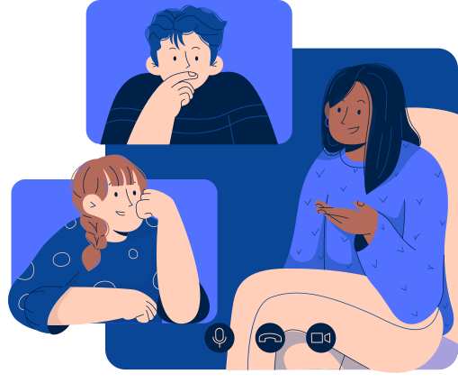
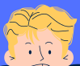
We identified a range of different locations people found to be more disabling, such as supermarkets, or enabling, such as green spaces, as well as six principles that underlie this. To learn more about these principles and how they relate to different public places, and some key questions we have posed to help businesses start to think about how they could better support autistic people in their spaces, visit our website at www.sensorystreet.uk
What We Learnt

“They [neurotypical people] think I actually have the ability to ignore things like smells and noises. And they underestimate how PAINFUL it is!”
Social Media Post

On social media, autistic people explained to us that their responses to an environment or a specific sensory input can vary over time. This means that one day someone can cope with a specific input or location while at other times it can be overwhelming (and this can change even over the course of the day). People also highlighted how every autistic person is unique. Therefore, what one person might enjoy might be something another person finds more challenging.

Over 86% of people who responded reported that they feel neurotypical people underestimate the impact of negative sensory environments on autistic people. They highlighted how negative sensory inputs are not just ‘annoying’ but can be truly painful. Individuals identified that neurotypical people often assume that autistic people are exaggerating and assume that autistic people can ignore or cope with difficult inputs in the way that they can.

People highlighted that as well as pain, managing challenging sensory environments can lead to other physical responses. Some reported that they can find it difficult to speak, while others reported feeling sick and fatigued. One person identified the negative consequences can be long-lasting, reporting that even if they can cope in the short term, it’s a ‘buildup of distress that makes me erupt later in my lonesome’.

In our collaboration with Queensmill School, staff highlighted that the attitudes of other people in public spaces can have more of an impact than the environment itself. People can be unpredictable (such as standing too close to you) and critical towards people experiencing difficulties with the sensory environment. This can exacerbate difficult situations and add to a person’s stress while being in a public space.

For someone who does not experience strong physical responses to a sensory environment, it can be difficult to imagine the impact it might have on someone with sensory processing differences. Our project shows why it is important to talk to autistic people about their perspectives and for people to learn more about how challenging sensory environments can make certain public places disabling or less accessible.

The Team


Cathy Manning
Principal Investigator and Lecturer, University of Reading


Becky Lyddon
Research Collaborator and founder of Sensory Spectacle

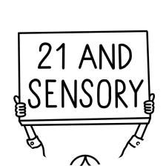

Emily
Research Collaborator and founder of @21andsensory


Jess Starns
Research Collaborator and founder of Dyspraxic Me


Catherine Woolley
Research and Engagement Officer, University of Oxford



Keren McLennan
Research Collaborator and Postdoctoral Researcher, University of Reading


Brett Heasman
Research Collaborator and Senior Lecturer at York St. John University



Raveen Rayat
Research Assistant, University of Reading

Contact

Lead Researcher:
Cathy Manning (Currently on Maternity Leave)
catherine.manning@psy.ox.ac.uk

Research and Engagement Officer:
Catherine Woolley
Catherine.woolley@psy.ox.ac.uk

Contact Information:

www.sensorystreet.uk

sensorystreet@psy.ox.ac.uk

@sensory_street


@sensory_street

@sensory street

Department of Experimental Psychology, Anna Watts Building, Woodstock Rd, Oxford OX2 6GG

Thank you to all our participants who engaged with both our social media posts and were involved in our series of focus groups. We would also like to thank those who were involved in our research feedback groups for their contribution.

We would also like to thank PEARL (Person-Environment-Activity Research Laboratory, UCL) for this support in creating and hosting our immersive event in July 2022.



References

- Department of Health Northern Ireland. (2022). Prevalence of Autism (including Asperger Syndrome) in School Age Children in Northern Ireland. Retrieved from: https://www.health-ni.gov.uk/articles/autism-statistics

- Department of Health and Social Care and Department for Education (2021). National strategy for autistic children, young people and adults: 2021 to 2026. Retrieved from: https://www.gov.uk/government/publications/national-strategy-for-autistic-children-young-people-and-adults-2021-to-2026

- Hazen, E. P., Stornelli, J. L., O'Rourke, J. A., Koesterer, K., & McDougle, C. J. (2014). Sensory symptoms in autism spectrum disorders. Harvard review of psychiatry, 22(2), 112–124. https://doi.org/10.1097/01.HRP.0000445143.08773.58

- Maenner, M. J., Shaw, K. A., Bakian, A. V., Bilder, D. A., Durkin, M. S., Esler, A., Furnier, S. M., Hallas, L., Hall-Lande, J., Hudson, A., Hughes, M. M., Patrick, M., Pierce, K., Poynter, J. N., Salinas, A., Shenouda, J., Vehorn, A., Warren, Z., Constantino, J. N., DiRienzo, M., … Cogswell, M. E. (2021). Prevalence and Characteristics of Autism Spectrum Disorder Among Children Aged 8 Years - Autism and Developmental Disabilities Monitoring Network, 11 Sites, United States, 2018. Morbidity and mortality weekly report. Surveillance summaries (Washington, D.C. : 2002), 70(11), 1–16. https://doi.org/10.15585/mmwr.ss7011a1

- Roman-Urrestarazu, A., van Kessel, R., Allison, C., Matthews, F. E., Brayne, C., & Baron-Cohen, S. (2021). Association of Race/Ethnicity and Social Disadvantage With Autism Prevalence in 7 Million School Children in England. JAMA pediatrics, 175(6), e210054. https://doi.org/10.1001/jamapediatrics.2021.0054

- Zeidan, J., Fombonne, E., Scorah, J., Ibrahim, A., Durkin, M. S., Saxena, S., Yusuf, A., Shih, A., & Elsabbagh, M. (2022). Global prevalence of autism: A systematic review update. Autism research : official journal of the International Society for Autism Research, 15(5), 778–790. https://doi.org/10.1002/aur.2696

